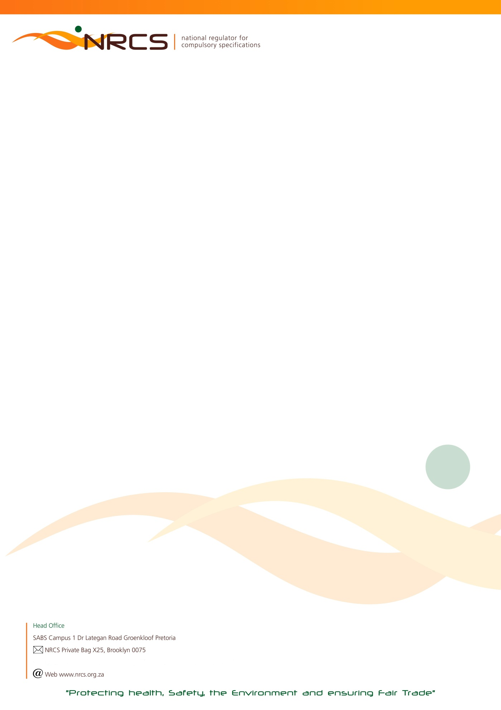

RETURN OF COMMODITIES ON WHICH LEVY IS PAYABLE FOR THE LEVY PERIOD:

1 JULY 2018 TO 31 DECEMBER 2018 (18B) DUE DATE: 31 JANUARY 2019

Urgent Attention: Financial / Import / Shipping Manager

Manufacturer/ Importer name HEF Number  Postal address  JDE Number  Postal code | Contact Numbers in case of queries:  Tel: 012 482 8890 (Lubabalo)  012 482 8903 (John)

In the interest of public health and safety the Minister of Trade and Industry has approved compulsory specifications for a number of commodities which are administered and maintained by the National Regulator for Compulsory Specifications (NRCS).

According to the NRCS Act No 5 of 2008, any person who imports, sells or supplies a commodity, product or service to which a compulsory specification applies, must:
- keep or supply to the NRCS such records as may be prescribed by the Minister;
- pay such fees to the NRCS as may be prescribed by the Minister after consultation with the Minister of Finance.

Calculation of Levy Payable:
Total Quantity Manufactured and/or Imported X Applicable Commodity Tariff. Quantities are based on manufacture* and/or importation and not on sales. Levy tariffs increase annually and published in the Government Gazette.

- The return must be completed and signed by a duly authorized signatory within the company.

- Any manufacturer or importer to whom this return is addressed, is obliged by regulation to COMPLETE AND RETURN it to the NRCS, also in the event of a NIL manufacture* or import. These returns are required to be completed and returned bi-annually.
Please complete both quarters July to September and October to December.

- If a manufacturer or importer fails to submit the return, the NRCS may estimate the quantity manufactured* or imported and hold the manufacturer or importer liable for the levy so calculated; provided that the payment of a levy on the basis of an estimate shall not absolve the manufacturer or importer from settling in full any additional amount that may be due to the NRCS.

- Non-submission of the completed return, regardless whether the calculated levy due was indeed transferred (paid) to the NRCS, may result in an administration fee being charged.

*The definition of manufacture according to the NRCS Act includes produce, assemble, alter, modify, adapt, convert, process or treat.

THE COMPLETED RETURN TOGETHER WITH YOUR PROOF OF PAYMENT FOR THE APPLICABLE LEVY DUE MUST REACH THE NRCS ON OR BEFORE 31 JANUARY 2019. AN INVOICE CAN ONLY BE PROCESSED ONCE THIS COMPLETED RETURN HAS BEEN RECEIVED.
PLEASE RETURN ALL PAGES AS SUBMITTED TO YOU. PLEASE NOTE THAT CHEQUE AND CASH PAYMENTS ARE NOT ACCEPTED.

PLEASE COMPLETE: I, (Initials and Surname)

- acknowledge that I am duly authorized to submit this return on behalf of the above-mentioned manufacturer or importer; and
- confirm that the particulars furnished herein are true and correct in every respect for which the amount of R …………………………. is due.

NB: FOR FINAL CALCULATIONS AND BANKING DETAILS OF THE NRCS, PLEASE PROCEED TO THE LAST PAGE OF THIS RETURN.

SIGNATURE CAPACITY CELL NUMBER DATE

To ensure the correctness of NRCS records you are requested to supply the following information.
Tel Number/s: | E-Mail (Accounts):
Street Address | Postal Address (if different from the above)

AA53/ 7140 – 2018/12/31 nrcs.pta

BU 7140 / 1 July to 31 December 2018 (B) Page 2 of 4 …
ELECTRICAL APPARATUS
PLEASE NOTE: TOTAL QUANTITY TO BE ROUNDED OFF TO THE NEXT FULL UNIT

Code | Description of commodity | Quantity Manufactured  July to Sept | Quantity  Imported  July to Sept | Quantity  Manufactured  Oct to Dec | Quantity Imported  Oct to Dec | Total | Unit | Tariff | Levy payable
7120 | Portable television antennae ( IEC 60065 / VC 8055) |  |  |  |  |  | 100 Items | R 9,16
7121 | Audio Equipment, e.g. Hi-Fi Systems, Radios, etc  (IEC 60065 / VC 8055) |  |  |  |  |  | 10 Items | R 6,59
7123 | Audio Equipment e.g. Hi-Fi Systems , Radios, etc – Energy Efficiency and Labelling (VC 9008) |  |  |  |  |  | 10 Items | R 12,58
7122 | Visual Equipment e.g. TVs, VCRs, DVD Players, etc.  (IEC 60065 / VC 8055) |  |  |  |  |  | Item | R 1,90
7124 | Visual Equipment e.g. TVs VCRs, DVD Players, etc. – Energy  Efficiency and Labelling (VC 9008) |  |  |  |  |  | Item | R 1,35
7209 | Lamp Control Gear* (VC 9087) |  |  |  |  |  | Item | R 0,59
7210 | Luminaires and Lighting Appliances, e.g. fluorescent, fixed, portable, hand-held lamps, lighting chains, flood lights,  Christmas tree lighting sets, etc. (IEC 60598 / VC 9012) |  |  |  |  |  | 10 Items | R 1,83
7211 | Lamp holders (VC 8011) |  |  |  |  |  | 100 Items | R 3,64
7212 | Starters for tubular fluorescent lamps (VC 8039) |  |  |  |  |  | 100 Items | R 1,83
7213 | Incandescent lamps (globes) (VC 8043) |  |  |  |  |  | 100 Items | R 1,83
7214 | Single-Capped Fluorescent Lamps (CFL)* (VC 9091) |  |  |  |  |  | 10 Items | R 1,67
7510 | Plugs (VC 8008) |  |  |  |  |  | 100 Items | R 1,83
7511 | Socket outlets (VC 8008) |  |  |  |  |  | 10 Items | R 1,83
7512 | Socket outlet adaptors, including “Janus” couplers (VC 8008) |  |  |  |  |  | 100 Items | R 12,80
7513 | Switches for Fixed installations (VC 8003) |  |  |  |  |  | 100 Items | R 10,99
7514 | Switches for Appliances (VC 8052) |  |  |  |  |  | 100 Items | R 3,64
7517 | Cord Sets with plug and appliance coupler (VC 8029) |  |  |  |  |  | 100 Items | R 14,66
7518 | Cord Extension Sets – without switches (VC 8029) |  |  |  |  |  | 10 Items | R 2,76
7519 | Cord Extension Sets – with switches (VC 8029) |  |  |  |  |  | 10 Items | R 4,95
7520 | Cord Extension Sets – with switches and MCCB (VC 8029) |  |  |  |  |  | 10 Items | R 16,10
7521 | Cord Extension Sets – with switches and ELPU (VC 8029) |  |  |  |  |  | 10 Items | R 19,05
7610 | Flexible Cords (VC 8006) |  |  |  |  |  | 100 Kg | R 5,49
7611 | Electric Cables - fixed installations, Medium Voltage (VC 8077)  Electric Cables - fixed installations Low Voltage (VC 8075) |  |  |  |  |  | 100 Kg | R 5,49

AA53/ 7140 – 2018/12/31 nrcs.pta

BU 7140 / 1 July to 31 December 2018 (B) Page 3 of 4

Code | Description of Commodity | Quantity Manufactured  July to Sept | Quantity  Imported  July to Sept | Quantity  Manufactured  Oct to Dec | Quantity Imported  Oct to Dec | Total | Unit | Tariff | Levy Payable
7710 | Moulded case circuit-breakers : Single pole (VC 8036) |  |  |  |  |  | 10 Items | R 2,02
7711 | Moulded case circuit-breakers : Double pole (VC 8036) |  |  |  |  |  | 10 Items | R 6,77
7712 | Moulded case circuit-breakers : Triple pole (VC 8036) |  |  |  |  |  | 10 items | R 9,53
7713 | Moulded case circuit-breakers: Four pole (VC 8036) |  |  |  |  |  | 10 Items | R 11,35
7719 | Transportable motor operated tools: e.g. table saw thickness planers etc. (IEC 61029) / VC 8055) |  |  |  |  |  | 10 Items | R 13,36
7720 | Hand-held electric power tools, e.g. lathes, saws, grinders, drills, electric gardening and agricultural equipment, etc.  (IEC 60745 / VC 8055) |  |  |  |  |  | 10 Items | R 10,80
7721 | Earth leakage protection units: Single phase (VC 8035) |  |  |  |  |  | 10 Items | R 15,76
7722 | Earth leakage protection units: Multi phase (VC 8035) |  |  |  |  |  | 10 Items | R 29,83
7810 | Appliance couplers (VC 8012) |  |  |  |  |  | 100 Items | R 5,49
7811 | Appliance – Small:  (e.g. Vacuum cleaners, heaters, electric irons, heated blankets, fans, hairdryers, kettles, motor-operated appliances, instantaneous water heaters, soldering irons, battery chargers etc.)  (IEC 60335 / VC 8055) |  |  |  |  |  | 10 Items | R 1,83
7813 | Appliance – Large:  (e.g. Freezers, refrigerators, dishwashers, washing machines, tumble dryers, air conditioning units, catering equipment, microwave ovens, stoves, etc.) (IEC 60335 / VC 8055) |  |  |  |  |  | Item | R 2,31
7817 | Appliance – Large:  (Only freezers, refrigerators, dishwashers, washing machines, tumble dryers, washer-dryer combinations, electric ovens and air conditioners) – Energy Efficiency and labeling (VC 9008 ) |  |  |  |  |  | Item | R 2,76
7815 | Hot water storage tanks for domestic use (VC 9006) |  |  |  |  |  | Item | R 2,31
7816 | Integral and close-coupled domestic solar water heaters  (VC 9004) |  |  |  |  |  | Item | R 6,37
7812 | Information Technology (IT) equipment and business systems, (e.g. computers, monitors, printers, copiers, fax machines,  scanners, modems, routers etc. (IEC 60950 / VC 8055) |  |  |  |  |  | Item | R 5,44
7814 | Information Technology (IT) components, e.g. power-supplies,  cell phone battery chargers, motherboards, etc.  (IEC 60950 / VC 8055) |  |  |  |  |  | 100 Items | R 56,76

AA53/ 7140 – 2018/12/31 nrcs.pta
BU 7140 / 1 July to 31 December 2018 (B) Page 4 of 4

TOTAL LEVY DUE R

PLUS, DEBIT (IF ANY) BROUGHT FORWARD R

LESS CREDIT (IF ANY) BROUGHT FORWARD R

PAYMENT ENCLOSED R

Please do not add VAT

IMPORTANT NOTES:
The NRCS is not VAT registered (VAT exempted). All invoice amounts are exclusive of VAT.
The NRCS is a Section 3(A) Public Entity and does not have a Company Registration Number.

BANKING DETAILS FOR NRCS LEVY PAYMENTS:
PAYABLE TO : NRCS (NATIONAL REGULATOR FOR COMPULSORY SPECIFICATIONS)

BANK : ABSA

ACCOUNT NO : 40 7216 1682
BRANCH : BROOKLYN
BRANCH CODE : 335345 or (632005)

Method of Payment:
Direct deposit or Electronic Transfer (EFT): Please always quote your JDE Account Number or HEF reference number which appears on
the front page of this return
NB: Cheque or Cash Payments will not be accepted

*Non-submission of this completed levy return regardless of payment to the NRCS bank account will result in an administration fee of R500.00 being charged to your levy account
Completed Levy Return Forms and Proof of Payment:
E- Mail or Fax for the attention of the contact person mentioned below
Contact Person: Lubabalo Ngamntwini
Fax to email*: 086 413 0348
Telephone Number: 012 482 8890
email Address: Lubabalo.Ngamntwini@nrcs.org.za
Postal Address: NRCS
Private Bag X25
Brooklyn
0075

