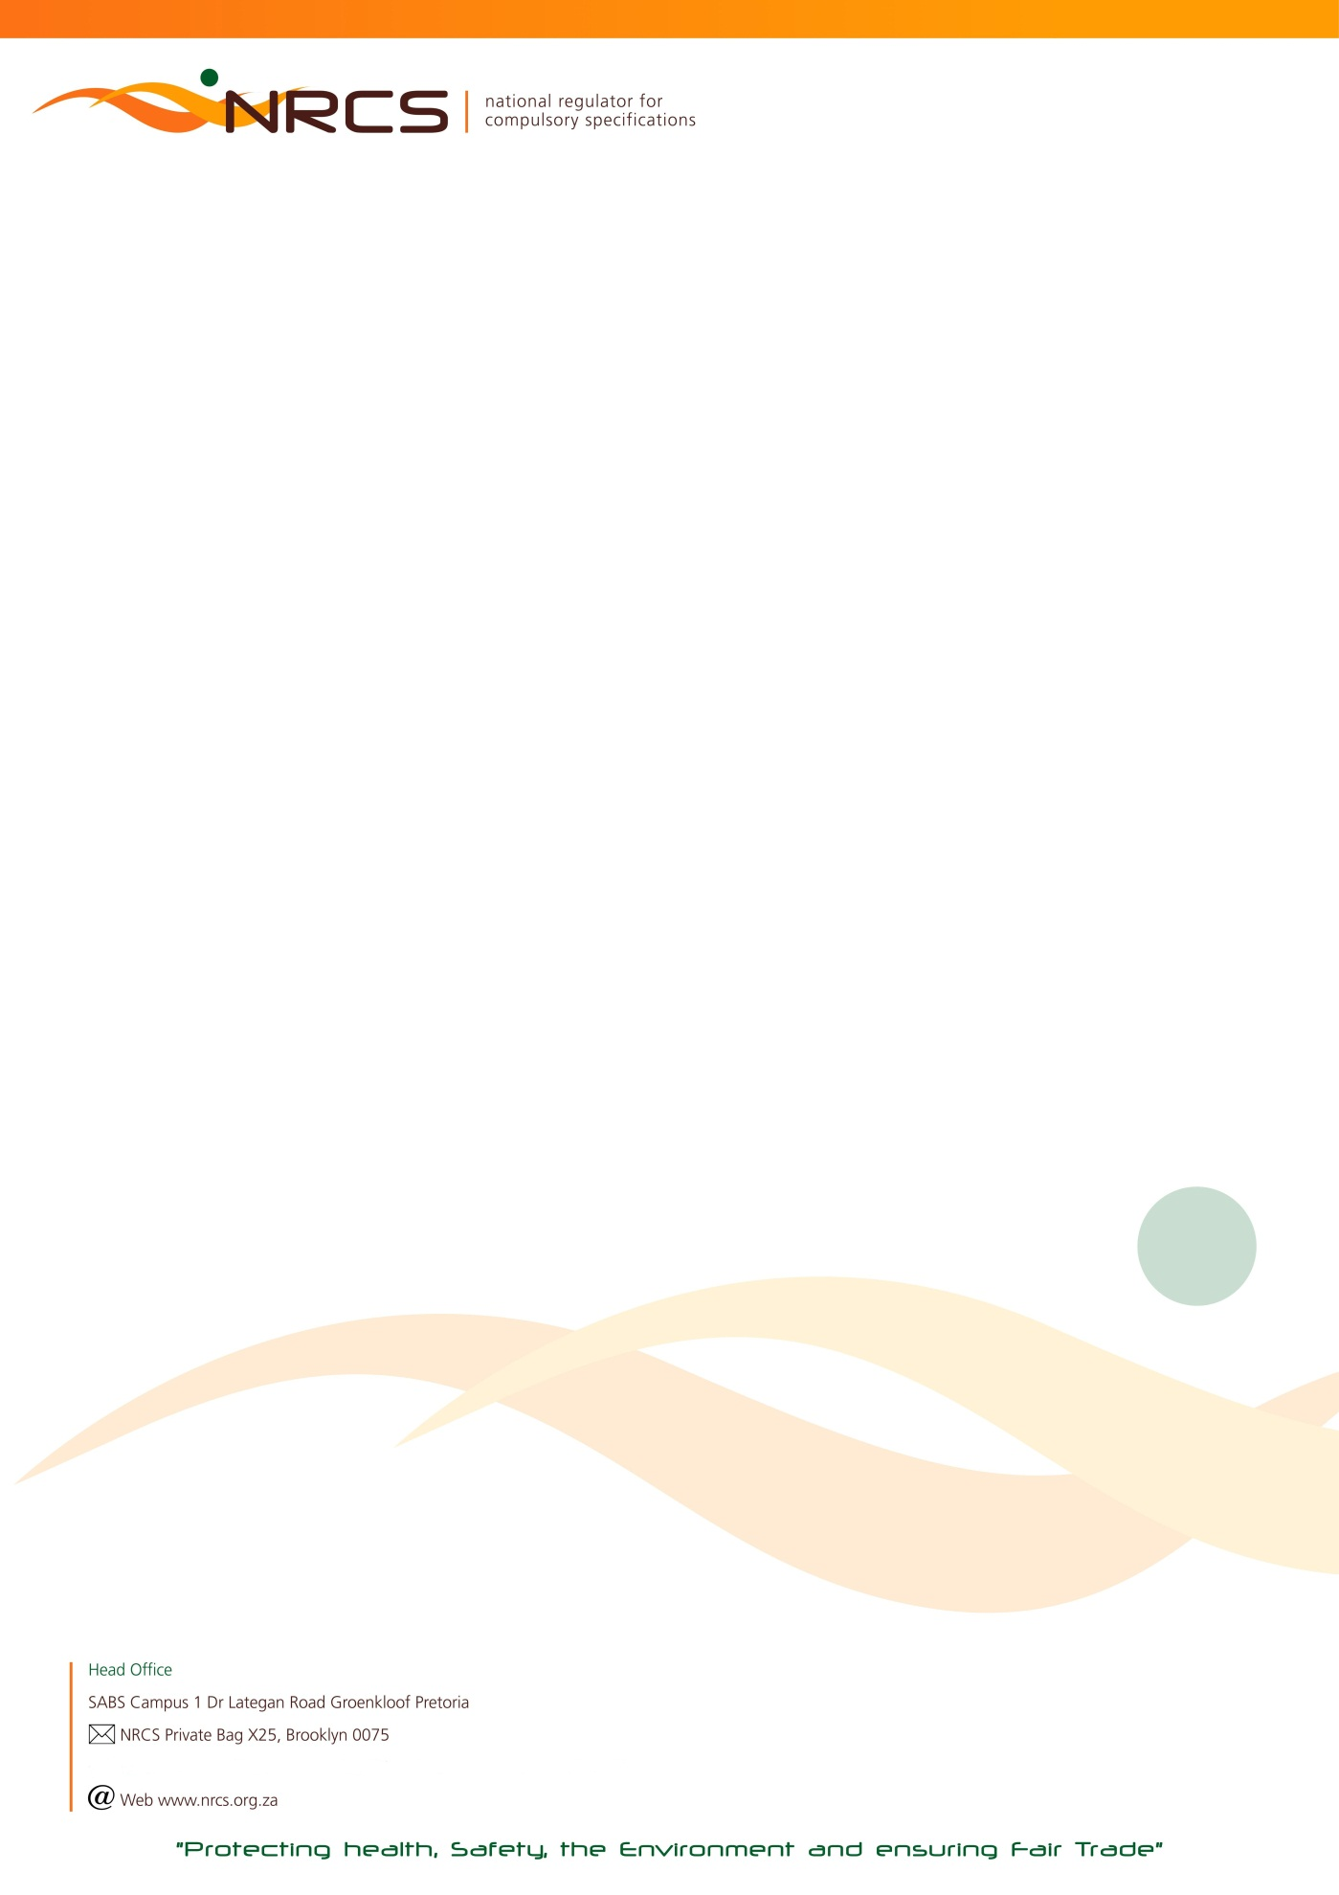

RETURN OF COMMODITIES ON WHICH LEVY IS PAYABLE FOR THE LEVY PERIOD:

1 JULY 2018 TO 31 DECEMBER 2018 (18B) DUE DATE: 31 JANUARY 2019

Urgent Attention: Financial / Import / Shipping Manager

Manufacturer/ Importer name HEF Number  Postal address  JDE Number  Postal code | Contact Numbers in case of queries:  Tel: 012 482 8903 (John)  012 482 8890 (Lubabalo)

In the interest of public health and safety the Minister of Trade and Industry has approved compulsory specifications for a number of commodities which are administered and maintained by the National Regulator for Compulsory Specifications (NRCS).

According to the NRCS Act No 5 of 2008, any person who imports, sells or supplies a commodity, product or service to which a compulsory specification applies, must:
- keep or supply to the NRCS such records as may be prescribed by the Minister;
- pay such fees to the NRCS as may be prescribed by the Minister after consultation with the Minister of Finance.

Calculation of Levy Payable:
Total Quantity Manufactured and/or Imported X Applicable Commodity Tariff. Quantities are based on manufacture* and/or importation and not on sales. Levy tariffs increase annually and published in the Government Gazette.

- The return must be completed and signed by a duly authorized signatory within the company.

- Any manufacturer or importer to whom this return is addressed, is obliged by regulation to COMPLETE AND RETURN it to the NRCS, also in the event of a NIL manufacture* or import. These returns are required to be completed and returned bi-annually.
Please complete both quarters January to March and April to June.

- If a manufacturer or importer fails to submit the return, the NRCS may estimate the quantity manufactured* or imported and hold the manufacturer or importer liable for the levy so calculated; provided that the payment of a levy on the basis of an estimate shall not absolve the manufacturer or importer from settling in full any additional amount that may be due to the NRCS.

- Non-submission of the completed return, regardless whether the calculated levy due was indeed transferred (paid) to the NRCS, may result in an administration fee being charged.

*The definition of manufacture according to the NRCS Act includes produce, assemble, alter, modify, adapt, convert, process or treat.

THE COMPLETED RETURN TOGETHER WITH YOUR PROOF OF PAYMENT FOR THE APPLICABLE LEVY DUE MUST REACH THE NRCS ON OR BEFORE 31 JULY 2017. AN INVOICE CAN ONLY BE PROCESSED ONCE THIS COMPLETED RETURN HAS BEEN RECEIVED.
PLEASE RETURN ALL PAGES AS SUBMITTED TO YOU. PLEASE NOTE THAT CHEQUE AND CASH PAYMENTS ARE NOT ACCEPTED.

PLEASE COMPLETE: I, (Initials and Surname)

- acknowledge that I am duly authorized to submit this return on behalf of the above-mentioned manufacturer or importer; and
- confirm that the particulars furnished herein are true and correct in every respect for which the amount of R …………………………. is due.

NB: FOR FINAL CALCULATIONS AND BANKING DETAILS OF THE NRCS, PLEASE PROCEED TO THE LAST PAGE OF THIS RETURN.

SIGNATURE CAPACITY CELL NUMBER DATE

To ensure the correctness of NRCS records you are requested to supply the following information.
Tel Number/s: | E-Mail (Accounts):
Street Address | Postal Address (if different from the above)
AA53/ 7138 – 2018/12/31 nrcs.pta

Page 1 of 4
FOODSTUFFS

PLEASE NOTE: TOTAL QUANTITY TO BE ROUNDED OFF TO THE NEXT FULL UNIT

 | Code | Description of commodity | Quantity  Manufactured  July to Sep | Quantity  Imported  July to Sep | Quantity  Manufactured  Oct to Dec | Quantity  Imported  Oct to Dec | Total | Unit | Tariff | Levy payable
 | 5710 | Canned crustaceans – Imports (VC 8014) |  |  |  |  |  | 1 000 kg | R767,00
 | 5711 | Canned fish and canned fish products (other than  fish paste) – Imports (VC 8014) |  |  |  |  |  | 1 000 kg | Sliding scale D
 | 5712 | Canned fish and canned fish products (other than  fish paste) – RSA products (VC 8014) |  |  |  |  |  | 1 000 kg | Sliding scale D
 | 5714 | Canned marine molluscs (other than abalone)  – Imports (VC 8014) |  |  |  |  |  | 1 000 kg | R696.00
 | 5715 | Canned marine molluscs (other than abalone)  – RSA products (VC 8014) |  |  |  |  |  | 1 000 kg | R696.00
 | 5716 | Canned meat and canned meat products – Imports (VC 8019) |  |  |  |  |  | 1 000 kg | Sliding scale A
 | 5717 | Canned meat and canned meat products  – RSA products (VC8019) |  |  |  |  |  | 1 000 kg | Sliding scale A
 | 5719 | Fish paste – Imports (VC 8014) |  |  |  |  |  | 1 000 kg | R165.00
 | 5720 | Fish paste – RSA products (VC 8014) |  |  |  |  |  | 1 000 kg | R165.00
 | 5721 | Frozen fish and frozen fish products – Imports (VC 8017) |  |  |  |  |  | 1 000 kg | Sliding scale B
 | 5722 | Frozen fish and frozen fish products – RSA products (VC 8017) |  |  |  |  |  | 1 000 kg | Sliding scale B
 | 5725 | Frozen unpackaged (loose) fish and ungutted,  boxed fish – RSA products & Imports (VC 8017) |  |  |  |  |  | 1 000 kg | Sliding scale C
 | 5727 | Frozen marine molluscs and frozen marine mollusc  products (other than mussels) – Imports (VC 8017) |  |  |  |  |  | 1 000 kg | R711.00
 | 5728 | Frozen marine molluscs and frozen marine mollusc  products (other than mussels) – RSA products (VC 8017) |  |  |  |  |  | 1 000 kg | R711.00
 | 5730 | Frozen rock lobster tails, leg and breast meat  –RSA products (VC 8020) |  |  |  |  |  | 10 kg | Sliding scale G
 |  |  |  |  |  |  |  |  |  | Page 2 of 4
 | Code | Description of commodity | Quantity  Manufactured  July to Sep | Quantity  Imported  July to Sep | Quantity  Manufactured  Oct to Dec | Quantity  Imported  Oct to Dec | Total | Unit | Tariff | Levy payable
 | 5748 | Frozen rock lobster tails, leg and breast meat –  Imports (VC8020) |  |  |  |  |  | 10 kg | Sliding scale G
 | 5734 | Frozen whole rock lobster, cooked and uncooked – RSA products (VC 8020) |  |  |  |  |  | 30 kg | Sliding scale G
 | 5749 | Frozen whole rock lobster, cooked and uncooked –  Imports (VC 8020) |  |  |  |  |  | 30 kg | Sliding scale G
 | 5736 | Smoked snoek – RSA products (VC 8021) |  |  |  |  |  | 1 000 kg | R235.00
 | 5739 | Frozen shrimps, prawns and langoustines – Imports (VC 8031) |  |  |  |  |  | 1 000 kg | Sliding scale E
 | 5740 | Frozen shrimps, prawns and langoustines –  RSA products (VC 8031) |  |  |  |  |  | 1 000 kg | Sliding scale E
 | 5741 | Frozen crabs – Imports (VC 8031) |  |  |  |  |  | 1 000 kg | Sliding scale E
 | 5742 | Frozen crabs – RSA products (VC8031) |  |  |  |  |  | 1 000 kg | Sliding scale E
 | 5743 | Frozen cephalopods – RSA products (VC 8017) |  |  |  |  |  | 1 000 kg | Sliding scale F
 | 5744 | Frozen cephalopods – Imports (VC 8017) |  |  |  |  |  | 1 000 kg | Sliding scale F
 | 5745 | Frozen mussels – Imports (VC 8017) |  |  |  |  |  | 1 000 kg | Sliding scale H
 | 5746 | Frozen mussels – RSA products (VC 8017) |  |  |  |  |  | 1 000 kg | Sliding scale H
 | 5751 | Canned abalone – Imports (VC 8014) |  |  |  |  |  | 1 000 kg | R951.00
 | 5752 | Canned abalone – RSA products (VC 8014) |  |  |  |  |  | 1 000 kg | R951.00
 | 5753 | Live Aquacultured Abalone (VC 9001) |  |  |  |  |  | 1000kg | R459.00
 | 5754 | Live lobster (VC 9104) |  |  |  |  |  | 1000kg | R501.00
Page 3 of 4

SLIDING SCALES – A TO H
TARIFFS PER UNIT
PLEASE NOTE: TOTAL QUANTITY TO BE ROUNDED OFF TO THE NEXT FULL UNIT.
SLIDING SCALE A | SLIDING SCALE B
R812,00 per unit for 1st ten (10) units;  R236,00 per unit for 11th to 60th unit;  R 208,00 per unit for each subsequent unit.  1 Unit = 1 000 kg | R736,00 per unit for 1st ten (10) units;  R168,00 per unit for 11th to 60th unit;  R 42,00 per unit for 61st to 560th unit;  R 26,00 per unit for each subsequent unit.  1 Unit = 1 000 kg
SLIDING SCALE C | SLIDING SCALE D
R440,00 per unit for 1st ten (10) units;  R 100,00 per unit for 11th to 60th unit;  R 24,00 per unit for 61st to 560th unit;  R 16,00 per unit for each subsequent unit.  1 Unit = 1 000 kg | R795,00 per unit for 1st ten (10) units;  R332,00 per unit for 11th to 60th unit;  R90,00 per unit for 61st to 560th unit;  R60,00 per unit for each subsequent unit.  1 Unit = 1 000 kg
SLIDING SCALE E | SLIDING SCALE F
R659,00 per unit for 1st twelve (12) units;  R390.00 per unit for each subsequent unit.  1 Unit = 1 000 kg | R742,00 per unit for 1st ten (10) units;  R157,00 per unit for each subsequent unit.  1 Unit = 1 000 kg
SLIDING SCALE G | SLIDING SCALE H
R327,00 per unit for 1st ten (10) units;  R20,00 per unit for each subsequent unit.  1 Unit = 10 kg or 30 kg | R669,00 per unit for 1st twenty (20) units;  R285,00 per unit for each subsequent unit.  1 Unit =1 000 kg

Page 4 of 4

TOTAL LEVY DUE R

PLUS, DEBIT (IF ANY) BROUGHT FORWARD R

LESS CREDIT (IF ANY) BROUGHT FORWARD R

PAYMENT ENCLOSED R

Please do not add VAT
IMPORTANT NOTES:
The NRCS is not VAT registered (VAT exempted). All invoice amounts are exclusive of VAT.
The NRCS is a Section 3(A) Public Entity and does not have a Company Registration Number.

BANKING DETAILS FOR NRCS LEVY PAYMENTS:
PAYABLE TO : NRCS (NATIONAL REGULATOR FOR COMPULSORY SPECIFICATIONS)

BANK : ABSA

ACCOUNT NO : 40 7216 1682
BRANCH : BROOKLYN
BRANCH CODE : 335345 or (632005)

Method of Payment:
Direct deposit or Electronic Transfer (EFT): Please always quote your JDE Account Number or HEF reference number which appears on
the front page of this return
NB: Cheque or Cash Payments will not be accepted
*Non-submission of this completed levy return regardless of payment to the NRCS bank account will result in an administration fee of
R500.00 being charged to your levy account
Completed Levy Return Forms and Proof of Payment:
E- Mail or Fax for the attention of the contact person mentioned below
Contact Person: JOHN TEMA
Fax to email*: 086 460 8125
Telephone Number: 012 482 8903
email Address: John.Tema@nrcs.org.za
Postal Address: NRCS
Private Bag X25
Brooklyn
0075

