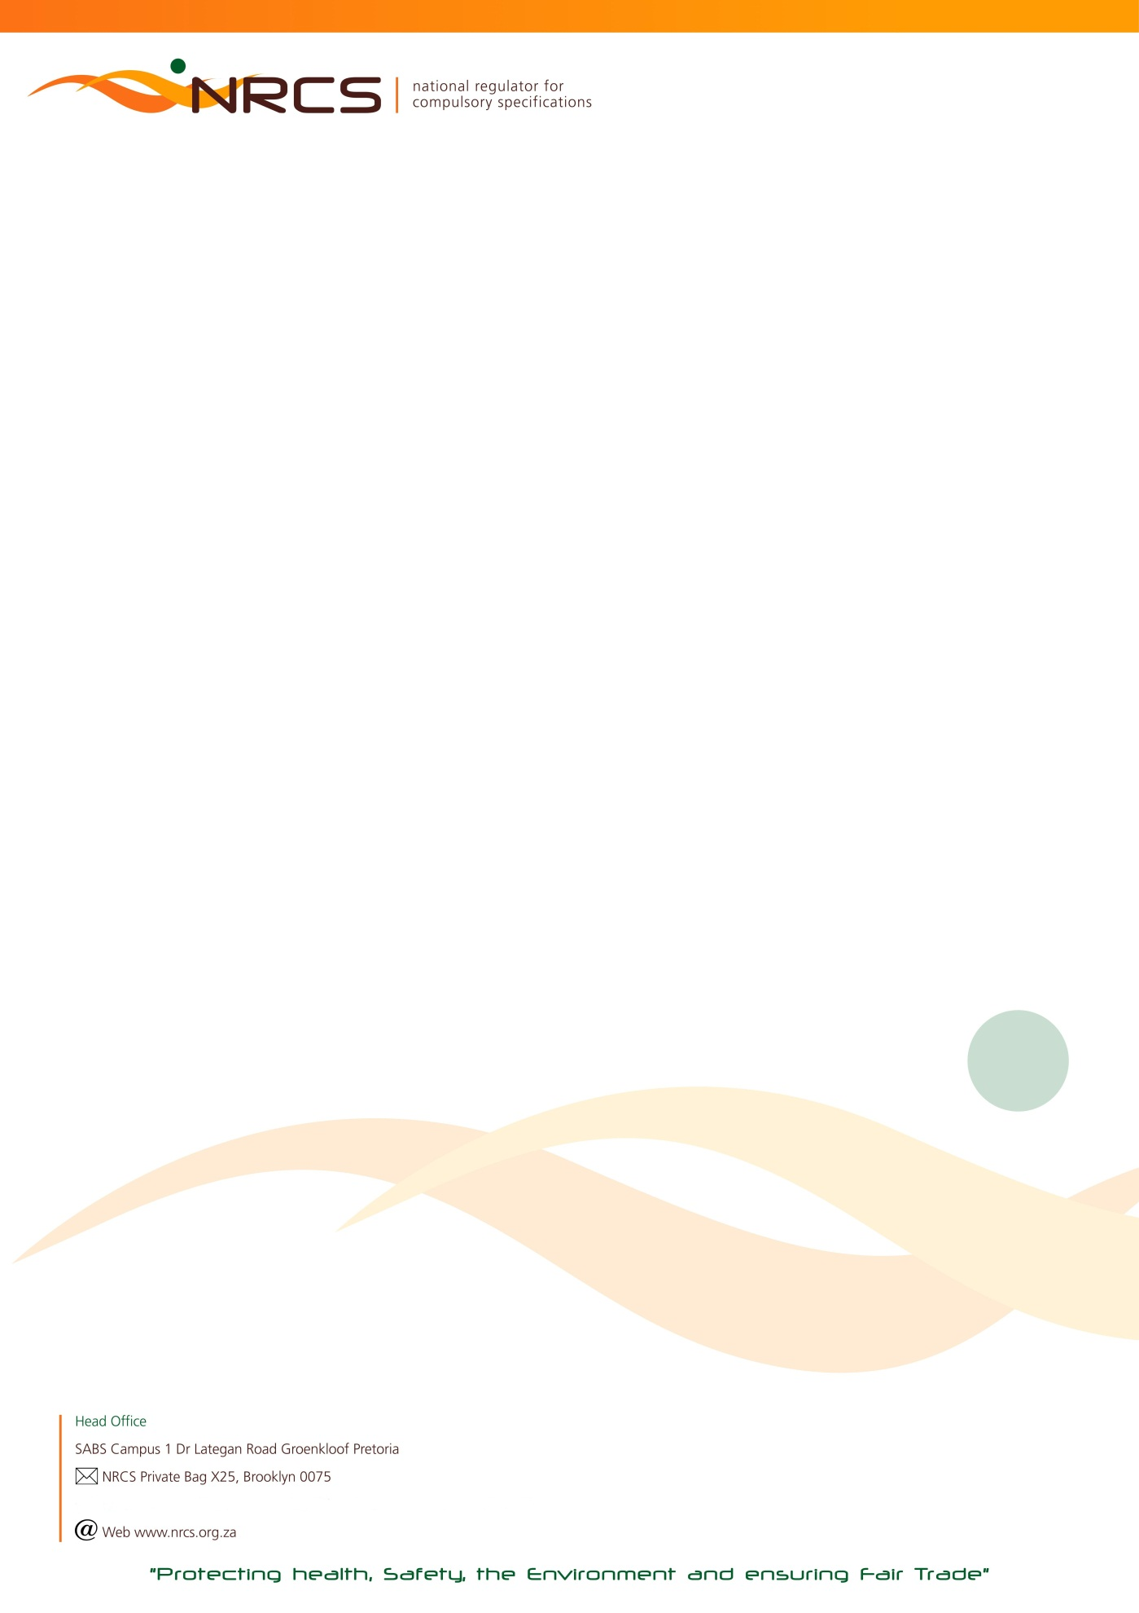

RETURN OF COMMODITIES ON WHICH LEVY IS PAYABLE FOR THE LEVY PERIOD:

1 JANUARY 2018 TO 30 JUNE 2018 (18A). TYPE 5 DUE DATE: 31 JULY 2018

Urgent Attention: Financial / Import / Shipping Manager

Manufacturer/ Importer name HEF Number  Postal address  JDE Number  Postal code | Contact Numbers in case of queries:  Tel: 012 482 8890 (Lubabalo)  012 482 8903 (John)

In the interest of public health and safety the Minister of Trade and Industry has approved compulsory specifications for a number of commodities which are administered and maintained by the National Regulator for Compulsory Specifications (NRCS).

According to the NRCS Act No 5 of 2008, any person who imports, sells or supplies a commodity, product or service to which a compulsory specification applies, must:
- keep or supply to the NRCS such records as may be prescribed by the Minister;
- pay such fees to the NRCS as may be prescribed by the Minister after consultation with the Minister of Finance.

Calculation of Levy Payable:
Total Quantity Manufactured and/or Imported X Applicable Commodity Tariff. Quantities are based on manufacture* and/or importation and not on sales. Levy tariffs increase annually and published in the Government Gazette.

- The return must be completed and signed by a duly authorized signatory within the company.

- Any manufacturer or importer to whom this return is addressed, is obliged by regulation to COMPLETE AND RETURN it to the NRCS, also in the event of a NIL manufacture* or import. These returns are required to be completed and returned bi-annually.
Please complete both quarters January to March and April to June.

- If a manufacturer or importer fails to submit the return, the NRCS may estimate the quantity manufactured* or imported and hold the manufacturer or importer liable for the levy so calculated; provided that the payment of a levy on the basis of an estimate shall not absolve the manufacturer or importer from settling in full any additional amount that may be due to the NRCS.

- Non-submission of the completed return, regardless whether the calculated levy due was indeed transferred (paid) to the NRCS, may result in an administration fee being charged.

*The definition of manufacture according to the NRCS Act includes produce, assemble, alter, modify, adapt, convert, process or treat.

THE COMPLETED RETURN TOGETHER WITH YOUR PROOF OF PAYMENT FOR THE APPLICABLE LEVY DUE MUST REACH THE NRCS ON OR BEFORE 31 JULY 2018. AN INVOICE CAN ONLY BE PROCESSED ONCE THIS COMPLETED RETURN HAS BEEN RECEIVED.
PLEASE RETURN ALL PAGES AS SUBMITTED TO YOU. PLEASE NOTE THAT CHEQUE AND CASH PAYMENTS ARE NOT ACCEPTED.

PLEASE COMPLETE: I, (Initials and Surname)

- acknowledge that I am duly authorized to submit this return on behalf of the above-mentioned manufacturer or importer; and
- confirm that the particulars furnished herein are true and correct in every respect for which the amount of R …………………………. is due.

NB: FOR FINAL CALCULATIONS AND BANKING DETAILS OF THE NRCS, PLEASE PROCEED TO THE LAST PAGE OF THIS RETURN.

SIGNATURE CAPACITY CELL NUMBER DATE

To ensure the correctness of NRCS records you are requested to supply the following information.
Tel Number/s: | E-Mail (Accounts):
Street Address | Postal Address (if different from the above)

AA53/ 7158 – 2018/06/30 nrcs.pta

BU 7158 - 1 January to 30 June 2018 (A) Type 5 Page 2 of 6 ………..

LIGHTERS FOR CIGARETTES, CIGARS AND PIPES

Code | Description of commodity | Quantity manufactured  Jan to March | Quantity imported  Jan to March | Quantity  Manufactured  Apr to June | Quantity Imported  Apr to June | Total | Unit | Tariff | Levy payable
4510 | Disposable lighters (for cigarettes, cigars and pipes) (VC 8076) |  |  |  |  |  | 100 Lighters | R 3,21
4511 | Refillable lighters (for cigarettes, cigars and pipes) (VC 8076) |  |  |  |  |  | 100 Lighters | R 3,21

FOOTWEAR

Code | Description of commodity | Quantity manufactured  Jan to March | Quantity imported  Jan to March | Quantity  Manufactured  Apr to June | Quantity Imported  Apr to June | Total | Unit | Tariff | Levy payable
46005 | Safety Footwear (VC 9002) |  |  |  |  |  | 1 Pair | R 0,32

BIOLOGICAL SAFETY CABINETS

Code | Description of commodity | Quantity manufactured  Jan to March | Quantity imported  Jan to March | Quantity  Manufactured  Apr to June | Quantity  Imported  Apr to June | Total | Unit | Tariff | Levy payable
5310 | Microbiological safety cabinets (Classes I, II and III) (VC 8041) |  |  |  |  |  | Item | R 4 761,00

COAL / PARAFFIN-BURNING APPLIANCES

Code | Description of commodity | Quantity manufactured  Jan to March | Quantity imported  Jan to March | Quantity  Manufactured Apr to June | Quantity  Imported  Apr to June | Total | Unit | Tariff | Levy payable
8110 | Coal-burning stoves and heaters (VC 8034) |  |  |  |  |  | Item | R 152,54
8120 | Non-pressure paraffin stoves and heaters (VC 9089) |  |  |  |  |  | Item | R 2,79
8130 | Pressurized paraffin fueled appliances (VC 9093) |  |  |  |  |  | Item | R 2,79

AA53/ 7158 – 2018/06/30 nrcs.pta

BU 7158 - 1 January to 30 June 2018 (A) Type 5 Page 3 of 6 ………..

FIRE-ARMS

Code | Description of commodity | Quantity manufactured  Jan to March | Quantity imported  Jan to March | Quantity  Manufactured  Apr to June | Quantity  Imported  Apr to June | Total | Unit | Tariff | Levy payable
8310 | .22 Rim fire arms (VC 8028) |  |  |  |  |  | Item | R 12,09
8311 | Revolvers (VC 8028) |  |  |  |  |  | Item | R 18,31
8312 | Centre fire rifles and pistols (VC 8028) |  |  |  |  |  | Item | R 18,31
8313 | Double-barrel shotguns (VC 8028) |  |  |  |  |  | Item | R 18,31
8314 | Single-barrel shotguns (VC 8028) |  |  |  |  |  | Item | R 15,58
8315 | All types of replacement barrels (VC 8028) |  |  |  |  |  | Item | R 12,09
8316 | Modified rim- and center fire rifles, revolvers and pistols (VC 8028) |  |  |  |  |  | Item | R 23,79
8317 | Modified double-barrel shotguns (VC 8028) |  |  |  |  |  | Item | R 23,79
8318 | Modified single-barrel shotguns (VC 8028) |  |  |  |  |  | Item | R 21,97

TIMBER

Code | Description of commodity | Quantity manufactured  Jan to March | Quantity imported  Jan to March | Quantity manufactured  Apr to June | Quantity  Imported  Apr to June | Total | Unit | Tariff | Levy payable
47105 | Preservative Treated Timber (VC 9092) |  |  |  |  |  | Per 1 m³ | R 1,20

CEMENT

Code | Description of commodity | Quantity manufactured  Jan to March | Quantity imported  Jan to March | Quantity  Manufactured  Apr to June | Quantity  Imported  Apr to June | Total | Unit | Tariff | Levy payable
8400 | Cement (VC 9085) |  |  |  |  |  | Per Metric  Ton | R 0,20

DISINFECTANTS & DETERGENTS

NB: QUANTITY TO BE ROUNDED OFF TO THE NEXT FULL UNIT!!

Code | Description of commodities | Quantity Manufactured  Jan to March | Quantity Imported  Jan to March | Quantity  Manufactured  Apr to June | Quantity  Imported  Apr to June | Total | Unit | Tariff | Levy payable
8700 | Disinfectants and Detergent-disinfectants (VC 8054) |  |  |  |  |  | 100 liters or 100 kg | R 6,59

AA53/ 7158 – 2018/06/30 nrcs.pta

BU 7158 - 1 January to 30 June 2018 (A) Type 5 Page 4 of 6………..

PERSONAL PROTECTIVE EQUIPMENT

Code | Description of commodities | Quantity manufactured  Jan to March | Quantity  Imported  Jan to March | Quantity  Manufactured  Apr to June | Quantity imported  Apr to June | Total | Unit | Tariff | Levy payable
8280 | Gas filters and combined filters (SANS 54387) (VC 8072) |  |  |  |  |  | Item | R 0,36
82802 | Filters for connection by means of breathing hoses to face pieces  (SANS 275 ) (VC 8072) |  |  |  |  |  | Item | R 0,36
8281 | Full-face masks (SANS 50136) (VC 8072) |  |  |  |  |  | Item | R 11,33
8282 | Half masks and quarter masks (SANS 50140) (VC 8072) |  |  |  |  |  | Item | R 1,35
8283 | Filtering half masks to protect against particles  (SANS 50149) (VC 8072) |  |  |  |  |  | Item | R 0,13
82830 | Valve filtering half masks to protect against gases or gases and particles (SANS 50405) (VC 8032) |  |  |  |  |  | Item | R 7,30
8284 | Half mask without inhalation valves and with separable filters to protect against gases or gases and particles or particles only  (SANS 51287) (VC 8072) |  |  |  |  |  | Item | R 1,35
8285 | Particle filters (SANS 50143) (VC 8072) |  |  |  |  |  | Item | R 0,28
8290 | Powered filtering devices incorporating a helmet or a hood  (SANS 12941) (VC 8072) |  |  |  |  |  | Item | R 118,50
82900 | Power assisted filtering devices incorporating full face masks, half masks or quarter masks (SANS 12942) (VC 8072) |  |  |  |  |  | Item | R 118,50
8291 | Compressed air line breathing apparatus for use with demand valve for use with a full face mask (SANS 54593-1) (VC 8072) |  |  |  |  |  | Item | R 74,85
82910 | Continuous flow compressed air line breathing apparatus  (SANS 54594) (VC 8072) |  |  |  |  |  | Item | R 74,85
82912 | Compressed air line breathing apparatus with demand valve for use with a half mask at positive pressure  (SANS 54593-2) (VC 8072) |  |  |  |  |  | Item | R 74,85
8292 | Fresh air hose breathing apparatus for use with full face mask, half mask or mouthpiece assembly (SANS 50138) (VC 8072) |  |  |  |  |  | Item | R 74,85
82920 | Powered fresh air hose breathing apparatus incorporating a hood  (SANS 50269) (VC 8072) |  |  |  |  |  | Item | R 74,85
8293 | Self-contained closed-circuit breathing apparatus of the compressed oxygen or compressed oxygen-nitrogen type  (SANS 50145) (VC 8072) |  |  |  |  |  | Item | R 1 116,00
8294 | Self-contained open-circuit compressed air breathing apparatus  (SANS 50137) (VC 8072) |  |  |  |  |  | Item | R 163,57
8295 | Self-contained closed-circuit breathing apparatus for escape apparatus (SANS 53794) (VC 8072) |  |  |  |  |  | Item | R 145,93
82951 | Self-contained open-circuit compressed air breathing apparatus with full face mask or mouthpiece assembly for escape  (SANS 50402) (VC 8032) |  |  |  |  |  | Item | R 224,50
82952 | Filtering devices with hood for self-rescue from fire  (SANS 50403) (VC 8032) |  |  |  |  |  | Item | R 30,48
82953 | Filter self-rescuers for protection against carbon monoxide  (SANS 50404) (VC 8032) |  |  |  |  |  | Item | R 15,24
82955 | Compressed air escape apparatus with a hood  (SANS 51146) (VC 8032) |  |  |  |  |  | Item | R 191,00

AA53/ 7158 – 2018/06/30 nrcs.pta
BU 7158 - 1 January to 30 June 2018 (A) Type 5 Page 5 of 6………..

SWIMMING AIDS / LIFE JACKETS

Code | Description of commodities | Quantity manufactured  Jan to March | Quantity imported  Jan to March | Quantity  Manufactured  Apr to June | Quantity  Imported  Apr to June | Total | Unit | Tariff | Levy payable
4310 | Swimming aids that are carried or worn on the body  (SANS 53138-1) (VC 8032) |  |  |  |  |  | Item | R 0,26
4312 | Swim seats (SANS 53138-3) (VC 8032) |  |  |  |  |  | Item | R 0,61
4314 | Buoyancy aids (level 50) (SANS 12402-5) (VC 8032) |  |  |  |  |  | Item | R 7,35
4315 | Special purpose buoyancy aids (SANS 12402-6) (VC 8032) |  |  |  |  |  | Item | R 7,35
4313 | Lifejackets for inland / close to shore conditions (level 100)  (SANS 12402-4) (VC 8032) |  |  |  |  |  | Item | R 14,69
43131 | Lifejackets for offshore conditions (level 150)  (SANS 12402-3) (VC 8032) |  |  |  |  |  | Item | R 14,69
43132 | Lifejackets for extreme offshore conditions (level 275)  (SANS 12402-2) (VC 8032) |  |  |  |  |  | Item | R 14,69
43133 | Lifejackets for seagoing ships (SANS 12402-1) (VC 8032) |  |  |  |  |  | Item | R 14,69
43134 | Special Purpose lifejackets (SANS 12402-6) (VC 8032) |  |  |  |  |  | Item | R 14,69

SAFETY GLASS / GLAZING MATERIALS

Code | Description of commodities | Quantity manufactured  Jan to March | Quantity  Imported  Jan to March | Quantity  manufactured  Apr to June | Quantity  Imported  Apr to June | Total | Unit | Tariff | Levy payable
4400 | Safety glass and other safety glazing material (VC 9003) |  |  |  |  |  | Per 1 m² | R 0,21

AA53/ 7158 – 2018/06/30 nrcs.pta

BU 7158 - 1 January to 30 June 2018 (A) Type 5 Page 6 of 6……….

N. CALCULATION TABLE & BANKING DETAILS

TOTAL LEVY DUE R

PLUS, DEBIT (IF ANY) BROUGHT FORWARD R

LESS CREDIT (IF ANY) BROUGHT FORWARD R

PAYMENT ENCLOSED R

PLEASE DO NOT ADD VAT!

IMPORTANT NOTES:
The NRCS is not VAT registered (VAT exempted). All invoice amounts are exclusive of VAT.
The NRCS is a Section 3(A) Public Entity and does not have a Company Registration Number.

BANKING DETAILS FOR NRCS LEVY PAYMENTS:
PAYABLE TO : NRCS (NATIONAL REGULATOR FOR COMPULSORY SPECIFICATIONS)

BANK : ABSA

ACCOUNT NO : 40 7216 1682
BRANCH : BROOKLYN
BRANCH CODE : 335345 or (632005)

Method of Payment:
Direct deposit or Electronic Transfer (EFT): Please always quote your JDE Account Number or HEF reference number which appears on
the front page of this return
NB: Cheque or Cash Payments will not be accepted

*Non-submission of this completed levy return regardless of payment to the NRCS bank account will result in an administration fee of R500.00 being charged to your levy account
Completed Levy Return Forms and Proof of Payment:
E- Mail or Fax for the attention of the contact person mentioned below
Contact Person: Lubabalo Ngamntwini
Fax to email*: 086 413 0348
Telephone Number: 012 482 8890
email Address: Lubabalo.Ngamntwini@nrcs.org.za
Postal Address: NRCS
Private Bag X25
Brooklyn
0075
AA53/ 7158 – 2018/06/30 nrcs.pta

