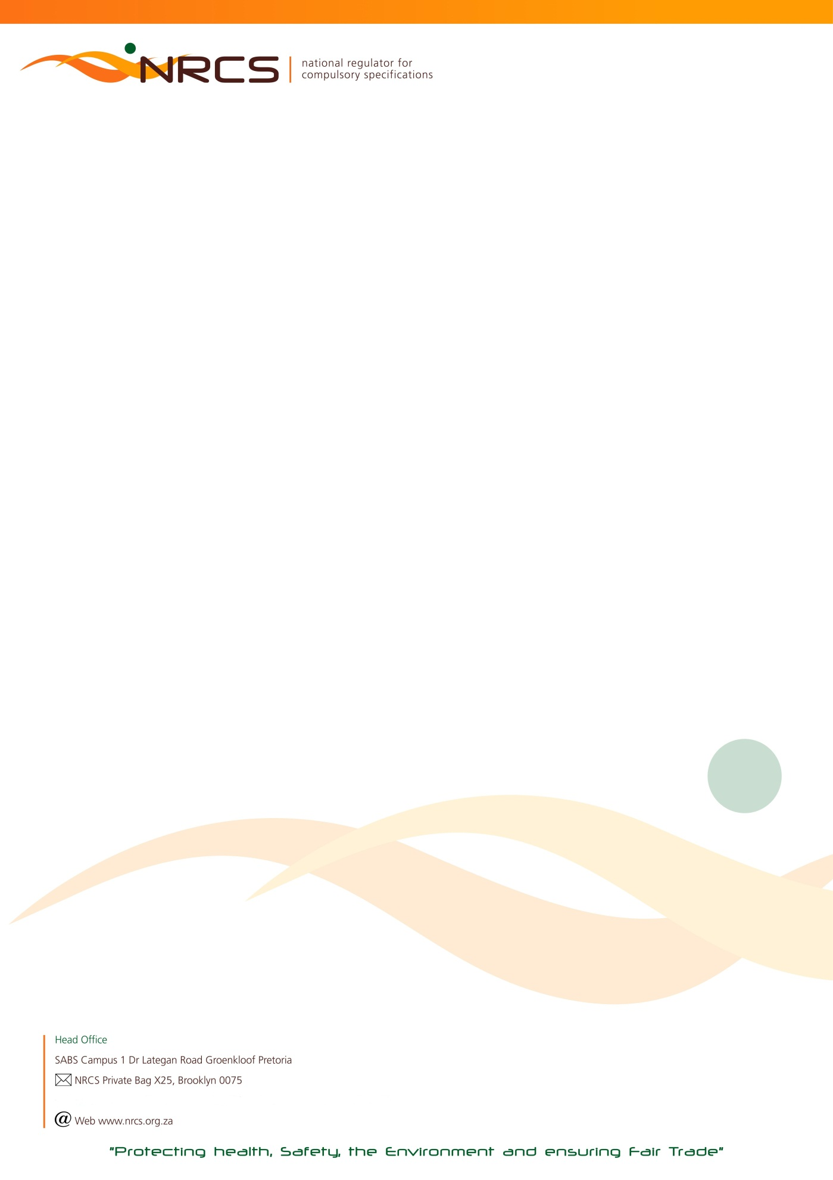

RETURN OF COMMODITIES ON WHICH LEVY IS PAYABLE FOR THE LEVY PERIOD:

1 JULY TO 31 DECEMBER 2018 (18B) DUE DATE: 31 JANUARY 2019

Urgent Attention: Financial / Import / Shipping Manager

Manufacturer/ Importer name HEF Number  Postal address  JDE Number  Postal code | Contact Numbers in case of queries:  Tel: 012 482 8903 (John)  012 482 8890 (Lubabalo)

In the interest of public health and safety the Minister of Trade and Industry has approved compulsory specifications for a number of commodities which are administered and maintained by the National Regulator for Compulsory Specifications (NRCS).

According to the NRCS Act No 5 of 2008, any person who imports, sells or supplies a commodity, product or service to which a compulsory specification applies, must:
- keep or supply to the NRCS such records as may be prescribed by the Minister;
- pay such fees to the NRCS as may be prescribed by the Minister after consultation with the Minister of Finance.

- Calculation of Levy Payable:
Total Quantity Manufactured and/or Imported X Applicable Commodity Tariff. Quantities are based on manufacture* and/or importation and not on sales. Levy tariffs increase annually and published in the Government Gazette.

- The return must be completed and signed by a duly authorized signatory within the company.

- Any manufacturer or importer to whom this return is addressed, is obliged by regulation to COMPLETE AND RETURN it to the NRCS, also in the event of a NIL manufacture* or import. These returns are required to be completed and returned bi-annually.
Please complete both quarters January to March and April to June.

- If a manufacturer or importer fails to submit the return, the NRCS may estimate the quantity manufactured* or imported and hold the manufacturer or importer liable for the levy so calculated; provided that the payment of a levy on the basis of an estimate shall not absolve the manufacturer or importer from settling in full any additional amount that may be due to the NRCS.

- Non-submission of the completed return, regardless whether the calculated levy due was indeed transferred (paid) to the NRCS, may result in an administration fee being charged.

*The definition of manufacture according to the NRCS Act includes produce, assemble, alter, modify, adapt, convert, process or treat.

THE COMPLETED RETURN TOGETHER WITH YOUR PROOF OF PAYMENT FOR THE APPLICABLE LEVY DUE MUST REACH THE NRCS ON OR BEFORE 31 JULY 2017. AN INVOICE CAN ONLY BE PROCESSED ONCE THIS COMPLETED RETURN HAS BEEN RECEIVED.
PLEASE RETURN ALL PAGES AS SUBMITTED TO YOU. PLEASE NOTE THAT CHEQUE AND CASH PAYMENTS ARE NOT ACCEPTED.

PLEASE COMPLETE: I, (initials and Surname)

- acknowledge that I am duly authorized to submit this return on behalf of the above-mentioned manufacturer or importer; and
- confirm that the particulars furnished herein are true and correct in every respect for which the amount of R …………………………. is due.

NB: FOR FINAL CALCULATIONS AND BANKING DETAILS OF THE NRCS, PLEASE PROCEED TO THE LAST PAGE OF THIS RETURN.

SIGNATURE CAPACITY CELL NUMBER DATE

To ensure the correctness of NRCS records you are requested to supply the following information.
Tel Number/s: | E-Mail (Accounts):
Street Address | Postal Address (if different from the above)
AA53/7156 – 2018/12/31 nrcs.pta

MOTOR VEHICLES
Code | Description of commodity | Quantity  Manufactured  Jul to Sep | Quantity  Imported  Jul to Sep | Quantity  Manufactured  Oct to Dec | Quantity  Imported  Oct to Dec | Total | Unit | Tariff | Levy payable
85200 | Category N1 (Light Commercial Vehicles) (VC 8024) |  |  |  |  |  | Item | R 19,64
85211 | Category N2 and N3 (Heavy Commercial Vehicles) (VC 8025) |  |  |  |  |  | Item | R 285,65
85222 | Category M1 (Passenger Vehicles) (VC8022) |  |  |  |  |  | Item | R 19,43
85233 | Category M2 (Buses) (VC 8023) |  |  |  |  |  | Item | R 316,44
852333 | Category M3 (Buses) (VC 8023) |  |  |  |  |  | Item | R 316,44
85244 | Category O1 - Trailers, GVM not exceeding 750 kg (VC 8026) |  |  |  |  |  | Item | R 34,14
85255 | Category O2 - Trailers, GVM 750 kg up to 3 500 kg (VC 8026) |  |  |  |  |  | Item | R 34,14
85266 | Category O3 -Trailers, GVM 3 500 kg up to 10 000 kg  (VC 8027) |  |  |  |  |  | Item | R 124,16
85267 | Category O4 – Trailers, GVM exceeding 10 000 kg (VC 8027) |  |  |  |  |  | Item | R 124,16
85277 | Custom built Bodies and Modifications/ Conversions  for vehicles in category M2 (Buses) (VC 8023) |  |  |  |  |  | Item | R 316,44
852777 | Custom built Bodies and Modifications/Conversions  for vehicles in category M3 (Buses) (VC 8023) |  |  |  |  |  | Item | R 316,44
85366 | Agricultural Tractors (Slow Moving Vehicles) (VC 8057) |  |  |  |  |  | Item | R 215,39
85377 | Custom built Bodies and Modifications/Conversions  for category M1 and N1 (Light Passenger and  Commercial Vehicles) (VC8022 & VC 8024) |  |  |  |  |  | Item | R 14,72
85388 | Custom built Bodies and Modifications/Conversions  for category N2 (Heavy Commercial Vehicles) (VC 8025) |  |  |  |  |  | Item | R 29,44
85399 | Custom built Bodies and Modifications/Conversions  for category N3 (Heavy Commercial Vehicles) (VC 8025) |  |  |  |  |  | Item | R 40,86
85400 | Motor Cycles L1 – L7 (VC 9098) |  |  |  |  |  | Item | R 58,16
Page 3 of 5

REPLACEMENT BRAKE / FRICTION MATERIAL – MOTOR VEHICLES

Code | Description of commodity | Quantity  Manufactured  Jul to Sep | Quantity  Imported  Jul to Sep | Quantity  Manufactured  Oct to Dec | Quantity  Imported  Oct to Dec | Total | Unit | Tariff | Levy payable
8528 | Replacement disc brake pad for categories M1 and N1  road vehicles (including minibuses) (VC 8053) |  |  |  |  |  | Axle set | R0,73
8534 | Replacement disc brake pad for categories M2  (excluding minibuses) M3, N2, N3, O2 O3 and (VC 8053)  O4 road vehicles |  |  |  |  |  | Axle set | R8,17
8530 | Replacement roll-stock friction material for categories  M, N and O road vehicles ( including minibuses) (VC 8053) |  |  |  |  |  | Per 1 m | R0,60
8529 | Replacement brake shoe friction material segment  for categories M, N and O road vehicles, (VC 8053)  and minibuses |  |  |  |  |  | Segment | R0,22
8535 | Replacement brake shoe friction material segment  for categories M2 (excluding minibuses), (VC 8053)  M3, N2, N3, O2, O3 and O4 road vehicles |  |  |  |  |  | Segment | R0,67

REPLACEMENT LIGHTS & SAFETY GLASS – MOTOR VEHICLES

Code | Description of commodity | Quantity  Manufactured  Jul to Sep | Quantity  Imported  Jul to Sep | Quantity  Manufactured  Oct to Dec | Quantity  Imported  Oct to Dec | Total | Unit | Tariff | Levy payable
8610 | Replacement secondary lights for motor vehicles (VC 8050) |  |  |  |  |  | Item | R2,26
8611 | Replacement headlights for motor vehicles (VC 8049) |  |  |  |  |  | Item | R3,45
8612 | Replacement incandescent lamps for motor vehicles (VC 8048) |  |  |  |  |  | Item | R0,14
8615 | Replacement halogen lamps for motor vehicles (VC 8048) |  |  |  |  |  | Item | R0,29
8613 | Replacement safety glass (laminated) for use in road vehicles  (VC 8051) |  |  |  |  |  | Item | R3,45
8614 | Replacement safety glass (toughened) for use in motor vehicles  (VC 8051) |  |  |  |  |  | Item | R2,26

Page 4 of 5

MOTORING REQUISITES

PLEASE NOTE: TOTAL QUANTITY TO BE ROUNDED OFF TO THE NEXT FULL UNIT (e.g. 45 liters of 100 liter = 1 UNIT)

Code | Description of commodities | Quantity  Manufactured  Jul to Sep | Quantity  Imported  Jul to Sep | Quantity  Manufactured  Oct to Dec | Quantity  Imported  Oct to Dec | Total | Unit | Tariff | Levy payable
3610 | Hydraulic brake and clutch fluid (VC 8013) |  |  |  |  |  | 100 liter | R8,28
3611 | Ball type couplings and towing brackets for  towing caravans and light trailers (VC 8065) |  |  |  |  |  | Item | R3,53
8210 | Child restraining devices for use in motor vehicles (VC 8033) |  |  |  |  |  | Item | R12,04
8410 | Elastomeric cups and seals for hydraulic brake  systems – Loose (VC 8080) |  |  |  |  |  | Per 100 | R8,98
8411 | Elastomeric cups and seals for hydraulic brake  systems – kit form (VC 8080) |  |  |  |  |  | Per Kit | R0,40
8510 | Safety helmets for motor cyclists (VC 8016) |  |  |  |  |  | Item | R4,04

TYRES

Code | Description of commodities | Quantity  Manufactured  Jul to Sep | Quantity  Imported  Jul to Sep | Quantity  Manufactured  Oct to Dec | Quantity  Imported  Oct to Dec | Total | Unit | Tariff | Levy payable
8230 | New tyres - for passenger vehicles and their trailers (VC 8056) |  |  |  |  |  | Item | R0,29
8231 | New tyres - for commercial vehicles and their trailers (VC 8059) |  |  |  |  |  | Item | R0,40

Page 5 of 5

TOTAL LEVY DUE R

PLUS, DEBIT (IF ANY) BROUGHT FORWARD R

LESS CREDIT (IF ANY) BROUGHT FORWARD R

PAYMENT ENCLOSED R

Please do not add VAT
IMPORTANT NOTES:
The NRCS is not VAT registered (VAT exempted). All invoice amounts are exclusive of VAT.
The NRCS is a Section 3(A) Public Entity and does not have a Company Registration Number.

BANKING DETAILS FOR NRCS LEVY PAYMENTS:
PAYABLE TO : NRCS (NATIONAL REGULATOR FOR COMPULSORY SPECIFICATIONS)

BANK : ABSA

ACCOUNT NO : 40 7216 1682
BRANCH : BROOKLYN
BRANCH CODE : 335345 or (632005)

Method of Payment:
Direct deposit or Electronic Transfer (EFT): Please always quote your JDE Account Number or HEF reference number which appears on
the front page of this return
NB: Cheque or Cash Payments will not be accepted

*Non-submission of this completed levy return regardless of payment to the NRCS bank account will result in an administration fee of
R500.00 being charged to your levy account
Completed Levy Return Forms and Proof of Payment:
E- Mail or Fax for the attention of the contact person mentioned below
Contact Person: JOHN TEMA
Fax to email*: 086 460 8125
Telephone Number: 012 482 8903
email Address: John.Tema@nrcs.org.za
Postal Address: NRCS
Private Bag X25
Brooklyn
0075

