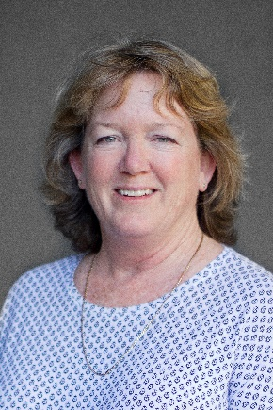
Dr Kirsty Carden
Future Water Institute, University of Cape Town
Kirsty Carden has over 30 years of experience working in academia, for government and the private sector in the field of urban water management. She is a Senior Research Officer in the Department of Civil Engineering at UCT and is currently the interim Director for UCT’s interdisciplinary research institute, Future Water. Her research interests include: urban water management and service provision in a South African context, sustainability assessment in water management, and integrated approaches geared towards sustainable urban development and water sensitive cities, including social learning related to water sensitive design.

