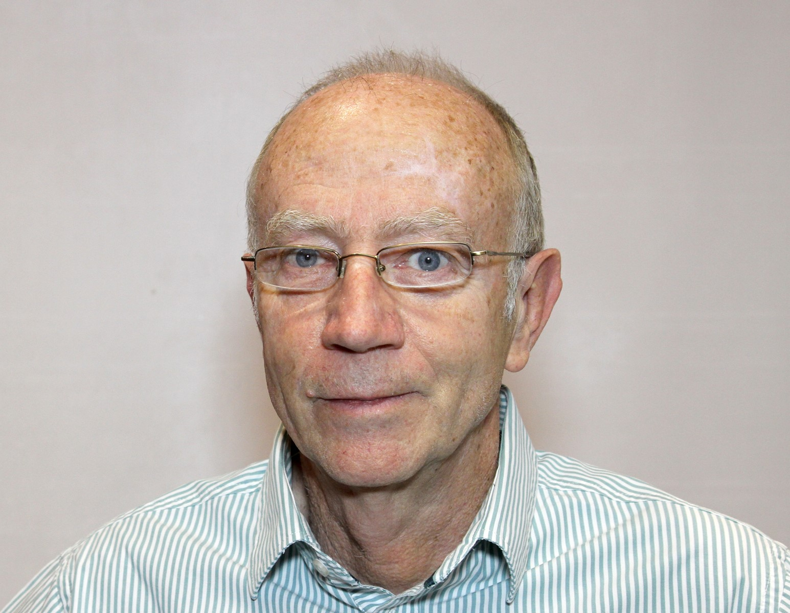

Dennis White
Dennis is the Executive Director responsible for the Southern African Metal Cladding and Roofing Association (SAMCRA) which is a sub-association of the Southern African Institute of Steel Construction (SAISC). He has almost fifty years of experience in different aspects of steel construction ranging from structural design through project management and sales to executive management. The last thirty five years have been spent in the metal cladding industry. During this latter period he has been involved in the design, marketing, manufacture and installation of cladding systems.
Dennis serves on several technical committees relating to building products and standards at the South African Bureau of Standards. He also participated in the rewrite of the Home Building Manual for the National Home Builders Registration Council (NHBRC).

